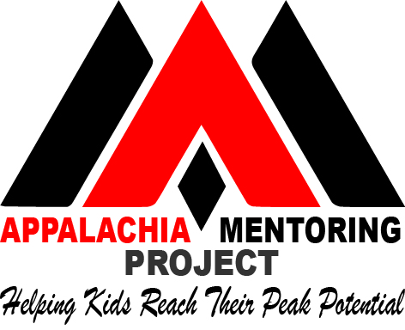

Church/AMP MOU

Purpose: To help children in Appalachia thrive physically, emotionally, spiritually, and academically through mentoring.

Desired Outcomes
- Create partnerships with the community so that the Gospel can be demonstrated through mentoring relationships with youth.
- Children attending church who need and want a role model can be connected in mentoring relationships with adults attending the church.
- To create and sustain a church-based mentoring team that can facilitate safe and effective mentoring relationships.

Church Responsibility:
- Pastor and board approval to sustain a mentoring ministry to youth in the church and in the community
- Work cooperatively with AMP to start and maintain a safe and effective mentoring ministry
- Select a team leader (from ministry staff or a key volunteer) who can:
  - Build a volunteer team to oversee the ministry – recruit, screen, match, and supervise
  - Manage the team
  - Stay focused on the mission and goals of the ministry
- 50/50 partnership
  - Half of the mentors are matched with children in the church who need and want a role model
  - Half of the mentors are matched from community referrals through AMP
- Background checks for matches within the church
- Liability insurance that covers mentoring
- Costs:
  - Background checks for all mentors
  - (If applicable) Staff time to organize and oversee mentoring team

AMP Responsibility:
- Train and support the mentoring team on the best practices of safe and effective mentoring
- Work with the team leader to oversee and support the team
- Match 50% of the mentors with children in the community.
- Provide access to ongoing training for teams

- Setup a mentoring management system
  - Mentor applications and references
  - Mentee application
  - Matching tools
  - Match supervision tools
  - Team communication tools
- Costs:
  - Staffing for training, community connections and overseeing church teams
  - Staffing for oversight of the mentoring management system

CAYM (Christian Association of Youth Mentoring) Responsibility:
- Provide training and support for AMP leadership
- Provide management and training materials for AMP and mentoring teams
- Offer webinars for team leaders and mentors
- Conduct ongoing Quality Assurance assessments

